TC-CSC-028
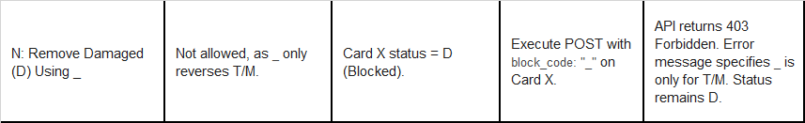
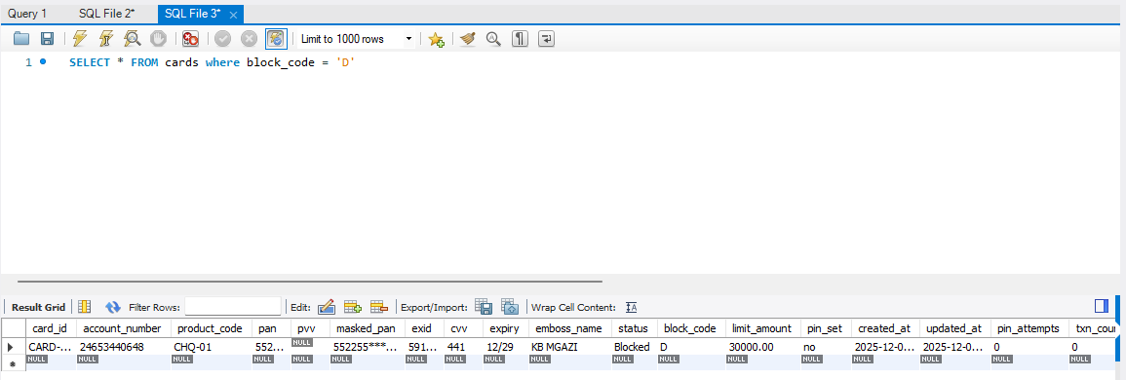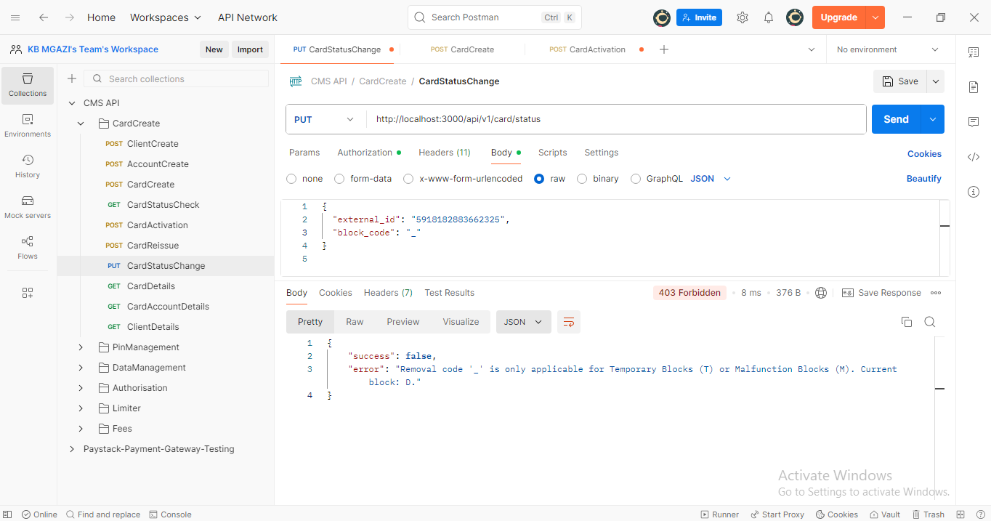
Request:
{
"external_id": "5918182883662325",
"block_code": "_"
}

Response:
{
"success": false,
"error": "Removal code '_' is only applicable for Temporary Blocks (T) or Malfunction Blocks (M). Current block: D."
}

